# Assignment 5

**Xtreme Team**

Dennis Grajo

Mike McColm

Stephen Obandinma

Hojun Lee

## White Box Test # 1 – Withdraw

1. **Code Section Being Tested**

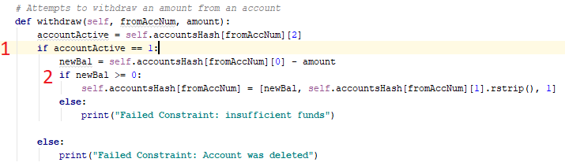

1. **Test** **Case** **Analysis**

For the withdraw method, the team has decided to use **decision** **coverage**. Since there are two if statements (marked above with 1 and 2), there will be 4 possible test cases. (True-True, True-False, False-True, False-False). These cases will cover all possible decisions in this method.

1. **Test Inputs**

|  |  |  |  |
| --- | --- | --- | --- |
| Test | Decision 1 (accountActive == 1) | Decision 2 (newBal > 0) | TSF statement |
| T1 | 1: true | 1: true | WDR 1234567 1000 0000000 *** |
| T2 | 1: false | 1: true | WDR 2468246 1000 0000000 *** |
| T3 | 2: true | 2: false | WDR 1234567 999999999 0000000 *** |
| T4 | 2: false | 2: false | WDR 2468246 999999999 0000000 *** |

1. **Test Results**

## White Box Test # 2 – Create

1. **Code Section Being Tested**

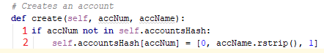

1. **Test** **Case** **Analysis**

For the create method, the team has decided to use statement coverage. Since there is only one statement plus the if statement, only two mutants need to be created as test inputs.

1. **Test Inputs**

|  |  |  |  |
| --- | --- | --- | --- |
| Test | Statement | Valid (Y/N) | TSF statement |
| T1a | 1 | Y | NEW 1234321 000 0000000 Bob #where accNum 1234321 doesn't exist) |
| T1b | 1 | N | NEW 1234567 000 0000000 Bob #where accNum 1234567 exists) |
| T2 | 2 | Y | NEW 1234321 000 0000000 Bob #where accNum 1234321 doesn't exist) |

1. **Test Results**

## Work Distribution

|  |  |  |
| --- | --- | --- |
| Member | Estimated Hours | Assignment Aspects |
| Dennis Grajo | 5 | Creating test cases and test inputs for the desired methods to test |
| Mike McColm | 5 | Small edits to created test cases and performing/analyzing the actual tests and results. |
| Stephen Obandinma |  |  |
| Hojun Lee |  |  |